**Worksheet #2.1**

Consider each figure and determine:

1. What does this visualization show?
2. What “tasks” does this visualization enable? (remember Alberto Cairo’s reading).
3. What are some limitations or potential problems with this visualization?
4. In which contexts would this be useful? In which contexts would another type of visualization be preferable?

**Fig 1**

A visualization of the average grade for three subjects (courses), obtained by all students in a degree programme. The error bar is the standard deviation.

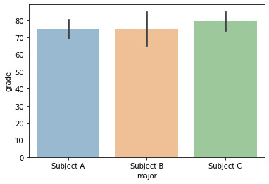

This visualization shows that:

1. The mean of each subject and their standard deviation
2. Enables comparison of the mean and SD between different subjects
3. No Max, no min, no IQR, difficult to visualise the SD, no number
4. This context good to find out average grade of course
   1. Distribution of students grades

**Fig 2**

The correlation between the grade the students obtained, and the feedback they gave to the lecturer in the course.

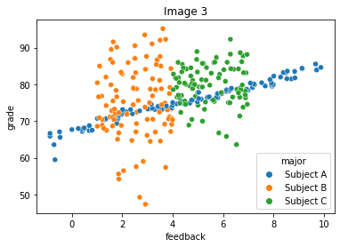

This visualization shows that:

1. Scatterplot of grade against feedback for each subject
2. Enable correlation of feedback and the grades for each subject
3. negative feedback
4. Comparing relationships

**Fig 3**

The feedback given by the students to a lecturer in a course over time, with the standard deviation as the shaded area.

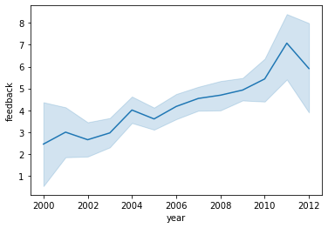

This visualization shows that:

1. a
2. b
3. No as precise, hard to compare
4. d